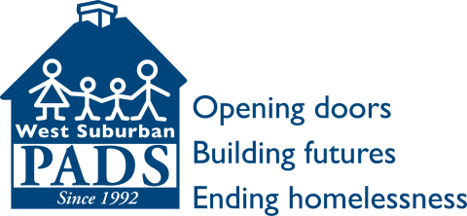
West Suburban PADS’
Open Door Housing Program
“House-to-Home” Kit
_____________________________________________________________________________________

Kitchen Cleaning supplies:
Dishes (set of 4) Toilet brush
Glasses All-purpose spray
Silverware Sponges (no scratch
Pots and pans scrubbing kind)
Cooking utensils Bucket
Knives for food preparation Mop
Can opener Broom
Cutting board Trash can and bags
Kitchen towels Paper towels
Coffee mugs Dish soap
Food storage containers Dusting spray
Toilet bowl cleaner
Small Appliances/Electronics Laundry soap and fabric
Toaster softener sheets
Microwave
Coffee Pot Personal Hygiene
Vacuum Tissues
TV/converter box (see Note below) Toilet paper
Bar soap
Bedroom Shampoo and conditioner
Bedding (full/queen) Toothbrush and toothpaste
Pillows Disposable razors (men’s)
Alarm clock radio Hand lotion
Hangers Deodorant
Nail clippers
Bathroom Shave gel or cream
Towels (4) Comb or brush
Hand towels
Wash cloths Miscellaneous
Non-slip mat for shower/tub Light bulbs
Shower curtain and hooks Calendar
Bath mat/rug Fan
Laundry basket or bag
Envelopes and stamps

West Suburban PADS’ donation policy requests that all soft items (pillows, bedding, towels, etc.) be purchased new.

Note: TVs are important “House-to-Home” items because they help our clients transition back to living alone in an apartment – often after congregant living in the Emergency Shelter. Watching television is one way they can re-establish their connections to the community and world around them.

Contact
ijohnson@westsuburbanpads.org or 708.338.1724

West Suburban PADS has been helping economically disadvantaged men, women, and families transition from homelessness to stable housing for 23 years. For more information about our work to open doors, build futures, and end homelessness in west Cook County visit us online at www.westsuburbanpads.org, Facebook.com/WSPADS or Twitter @WestSubPADS.

